 **Nile unvirsity**

**School of computer science and information technology**

**Csci 313 – Software Enginering**

**Reservation system for hotels**

**Team member:**

**Rewan Deabes (202001070)**

**Mahmoud Youssef (18102135)**

**Mark Magdy (202001770)**

**Mariam Ibrahem (19104858)**

**Abubakr Ahmed (202000209)**

**Submitted to:**

**DR: Ahmed El nokrashy**

**ENG.: Amira Tarek**

**Table of contents**

1. **Contents……………...……………………………………………2**
2. **Introduction……………………………………………………….3**

**2.1 Purpose of document…………………………………………3**

**2.2 Scope of project ………………………………………………3**

**2.3 Technologies Used ……………………………………………4**

**2.4 Intended Audience……………………………………………4**

**2.5 Over View of Document……………………………………...4**

**3- Overall description…………………………………………………...5**

**3.1 Product Perspective……………………………………………..5**

**3.2 Product Functions……………………………………………….5**

**3.3 User classes and characteristics………………………………...5**

**3.4 Operating environment………………………………………….6**

**3.5 Design and implementation constraint…………………………6**

**3.6 User documentation……………………………………...………6**

**4- Interfaces………………………………………………………………..6**

**4.1 System Interfaces…………………………………………………6**

**4.2 Software Interfaces……………………………………………….7**

**4.3 Hardware Interfaces……………………………………………..7**

# **Introduction:**

A hotel reservation system is a software that enables customers to make direct online reservations with the hotel without the need for middlemen by the use of web- and mobile-based program that lets users book hotels either online or through an app. Both quick access to client data **t**o manage room availability, pricing, rates andreservations.

## **Purpose of the document:**

The purpose of the document is giving an overview of what the end users can expect as well as how the system is supposed to function. With a thorough comprehension of the system and its functionality, the system can be developed for the end user and used to develop the project's later stages.

## **Scope of the project:**

The Hotel Reservation System aims to create an online hotel reservation application. End users (Customers and Hotel managers) and administrators can use this system to carry out a variety of functions, including easily and securely reserving hotel rooms. We have put the following facilities into spot. We have designed web page navigation in addition to the project's core functional requirements so that clients may search for rooms and reserve them or store them to their accounts to reserve later. a system for ranking the products in each category according to factors including location, number of views, price (from low to high), and rating. Additionally, a module for a customer feedback system for the products has been put in place.

## **Technologies used:**

We will use HTML, CSS, and JavaScript to build the front end and PHP to build the back end of our website in order to build our hotel reservation system. Besides this, we will use Flutter to build our mobile app, which will run on both OS and Android operating systems, as well as a SQL database to save our system data.

## **Intended audience:**

The intended audience of this project will be any person who would like to book a hotel room (customer), travel agencies, Receptionist, Hotel Manager and the Administrator.

## **Overview of the document:**

An overview in the product, the following chapter, which serves as the general descriptive portion of this document, gives a summary of the product characteristics. To introduce the technical requirements outlined in the following chapter, informal criteria are given. This document's requirements specification section, Chapter 3, offers technical descriptions that describe the functionality of the product and is largely targeted at developers.

**2. Overall Description:**

**2.1. Product Perspective:**

Hotel reservation system: a software that enables customers to make direct online reservations

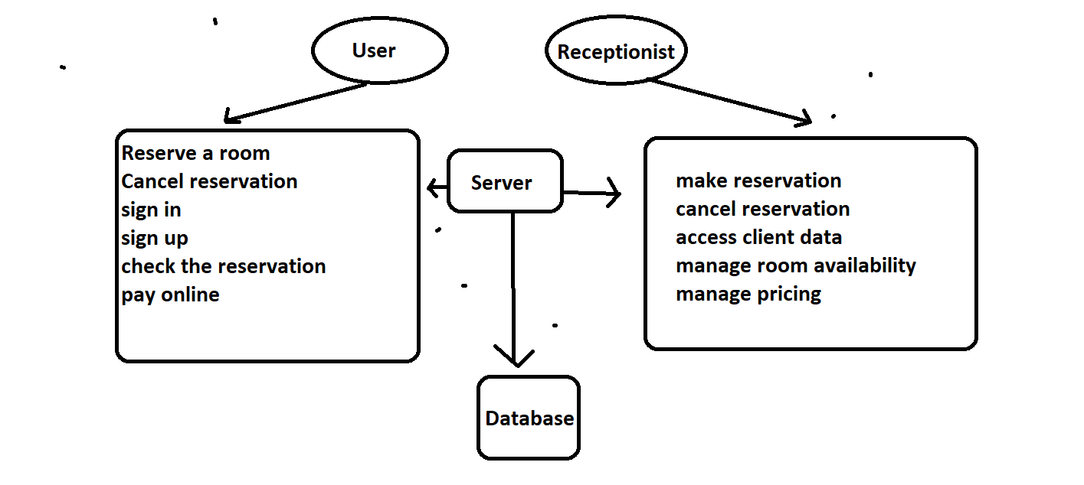

**2.2 Product functions:**

* Hotel Room Reservation
* Search for Specific Room
* Classification according to the size of the room , price ,the number of views and the rating
* Choose the Packages
* Select if the room is single or double or triple

## **2.3 User Classes and Characteristics:**

There are two main types of users that can interact with the system: -

1- The users of the system: customers who want to make an online reservation, or search a room. they are expected to have a valid email and to be able to fill their data and sign in to the website. They are also expected to know the basics of using a PC.

2-hotel manager and receptionists: they can check the reservation information/cancel reservation/ make a reservation/access to client data /manage room availability, pricing, rates. (They are expected to know the basics of using a PC)

**2.4** **Operating Environment:**

The system will run on all operating Systems

* For Development we use windows OS.
* For Deployment Android Mobile OS and Windows OS is used.

**2.5** **Design and Implementation Constraint:**

-The information of all the reservations, rooms, users must be stored in a database.

-The system is running 24 hours a day.

- Users may access from any computer that has an internet connection.

-users must have their correct usernames and passwords to sign in.

**2.6** **User Documentation:**

The SQL Database will be connected to the Application and it will be efficient and privacy to any Customer information or Hotel information

**3. Interfaces:**

**3.1 System interface:**

When a user starts the mobile application for the first time, they should see the log-in page. The user should be able to access the Sign-Up page if they are not logged into the system. So that they can use the system's features, they will create an account. If a user is not opening the application for the first time, they will be able to see the home page right away.

**3.2** **Software Interface:**

Hotel reservation system is a system that will be developed under the android, IOS, MAC, Windows operating systems environment using the HTML, CSS, and JavaScript. System interacts with database in the server side. System shall communicate with <PHP> to run <SQL> data queries.

**3.3** **Hardware Interface:**

The Hotel reservation system is an internet-based application. The mobile application requires a device that can connect to the internet and provide location services.

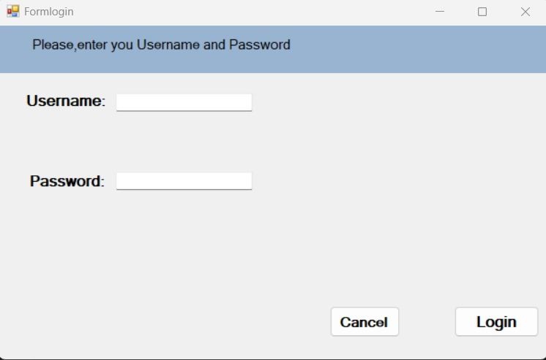

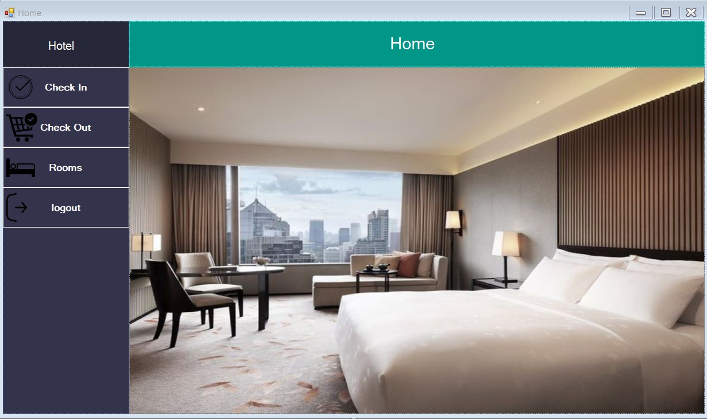

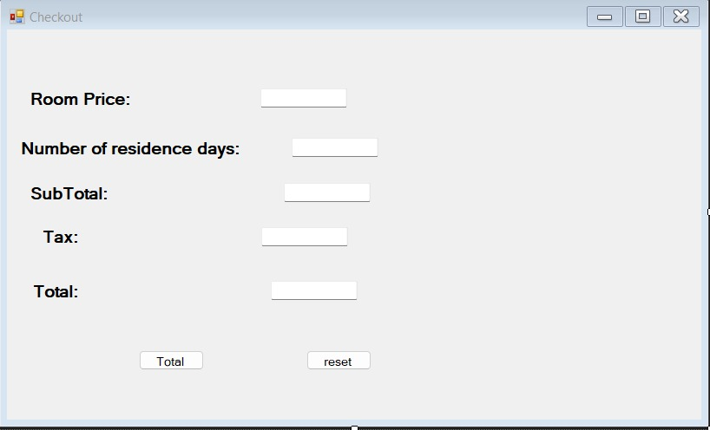

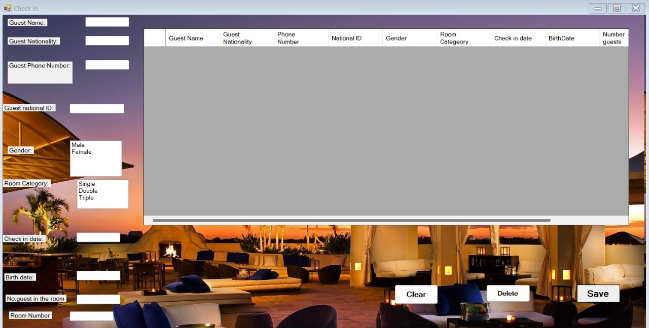

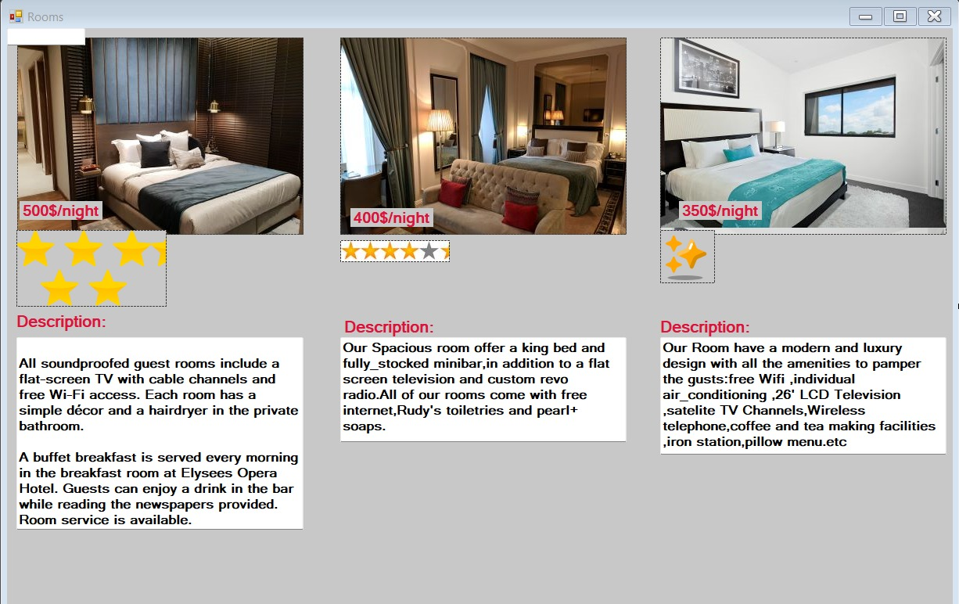

**4. Functional requirements:**

-the user can enter the wanted date and see all the available rooms in the hotel.

(Accept date and time to check available rooms for that particular time)

-the user can see the prices of each room.

-the user can request to serve a room.

-the user can pay online.

-the user can cancel reservation.

-the admin can add/delete/edit rooms.

-the admin can access users' private data.

-the admin can edit prices.

-the admin can reserve/cancel reservation for a customer.

-The system allows reservations to be changed without requiring the customer to resubmit all their information.

-the system Calculates and displays accommodation charges.

-the system Limits every account to a single user.

-the System should only allow users to move to payment only when mandatory fields such as date, time, location has been filled.

-the system should display for the admin the reserved rooms.

-the admin can see all the reservations information.

**5. Non-Functional:**

Record all actions, documents and reactions. The most important thing to note is that this technology allows visitors to select and book their rooms through a secure portal. The same convenience and flexibility must also be provided, which not only makes life easier, but also allows the data provided to be used to increase the hotel's business and profits.

The system must accept payments made using a variety of methods.

Accessible, efficient and easy to use

Use encryption to prevent bookings from bots.

Search results must appear within a reasonable time.

For invalid entries, users must be provided with appropriate assistance in completing required fields.

**6. Use Case diagram:**

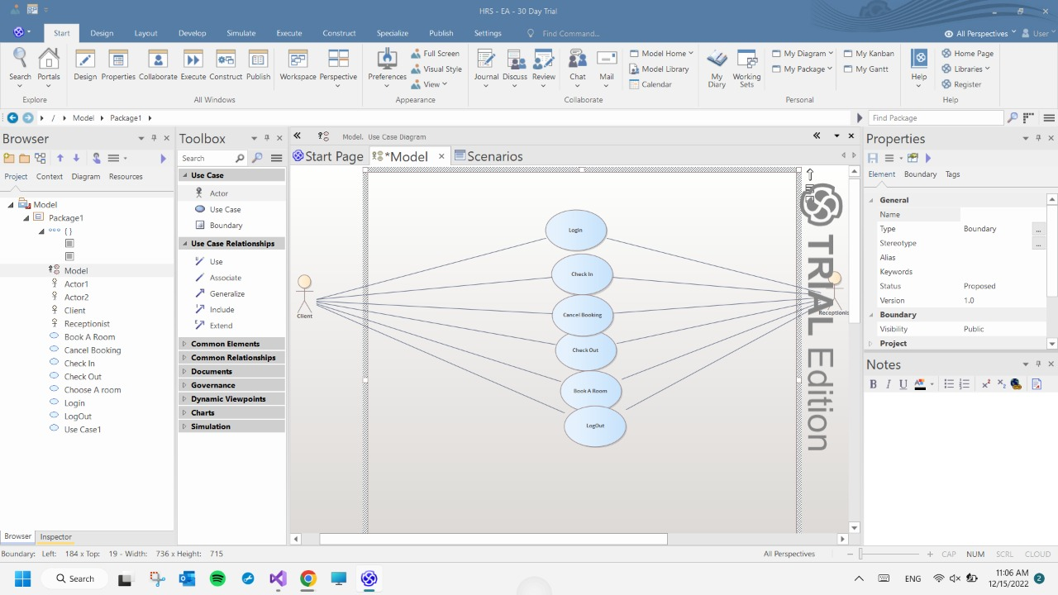

The Class Diagram:

The Sequence diagram:

First: the checkout

Second: the check in

The Scrum Retrospective video link on drive:

<https://1drv.ms/u/s!An2pMI2g-qznkEmv7ivuns-AeoMP?e=hYFEia>